Self-Administration of Medicines (SAM) form

IMPORTANT NOTE: Referral Agency Staff should complete the form on behalf of the client being referred.

The following form is for potential clients who are on any form of medication for physical or mental health conditions. If the potential client is not taking any medication, this form does not need to be filled out.

The referring agency must complete this form on behalf of the potential client and send it over with the referral and risk assessment. It should be made explicitly clear to the potential client that Voyant Virtues Supported Housing does not dispense medication and that they will be responsible for managing their own medication. This will be reiterated during the interview stage.

The bottom of the consent form must be signed by the Client.

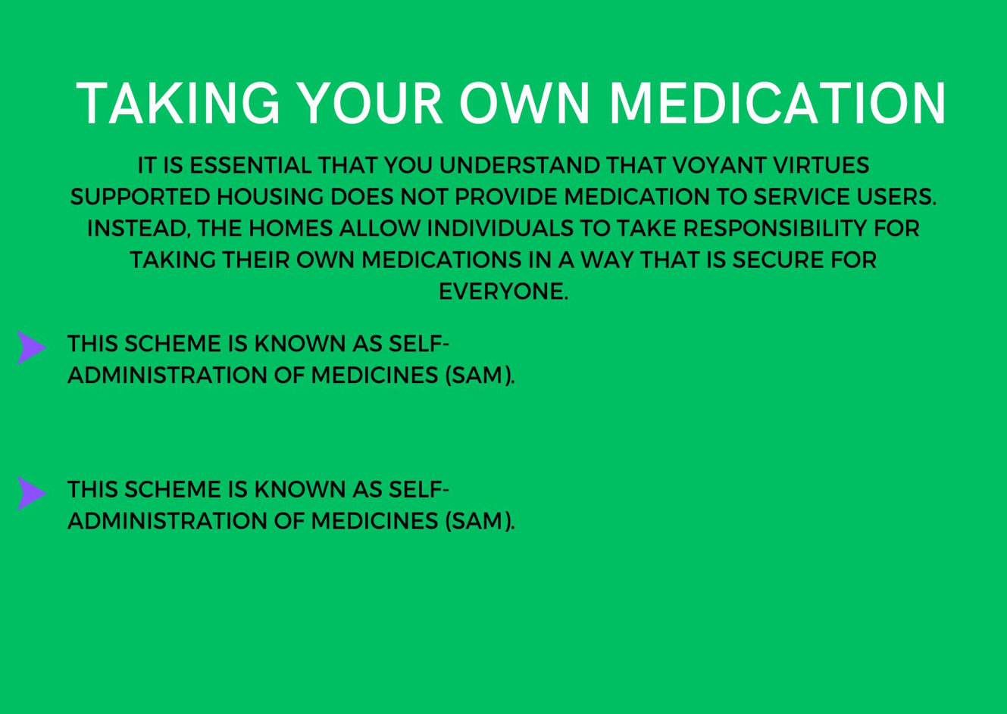

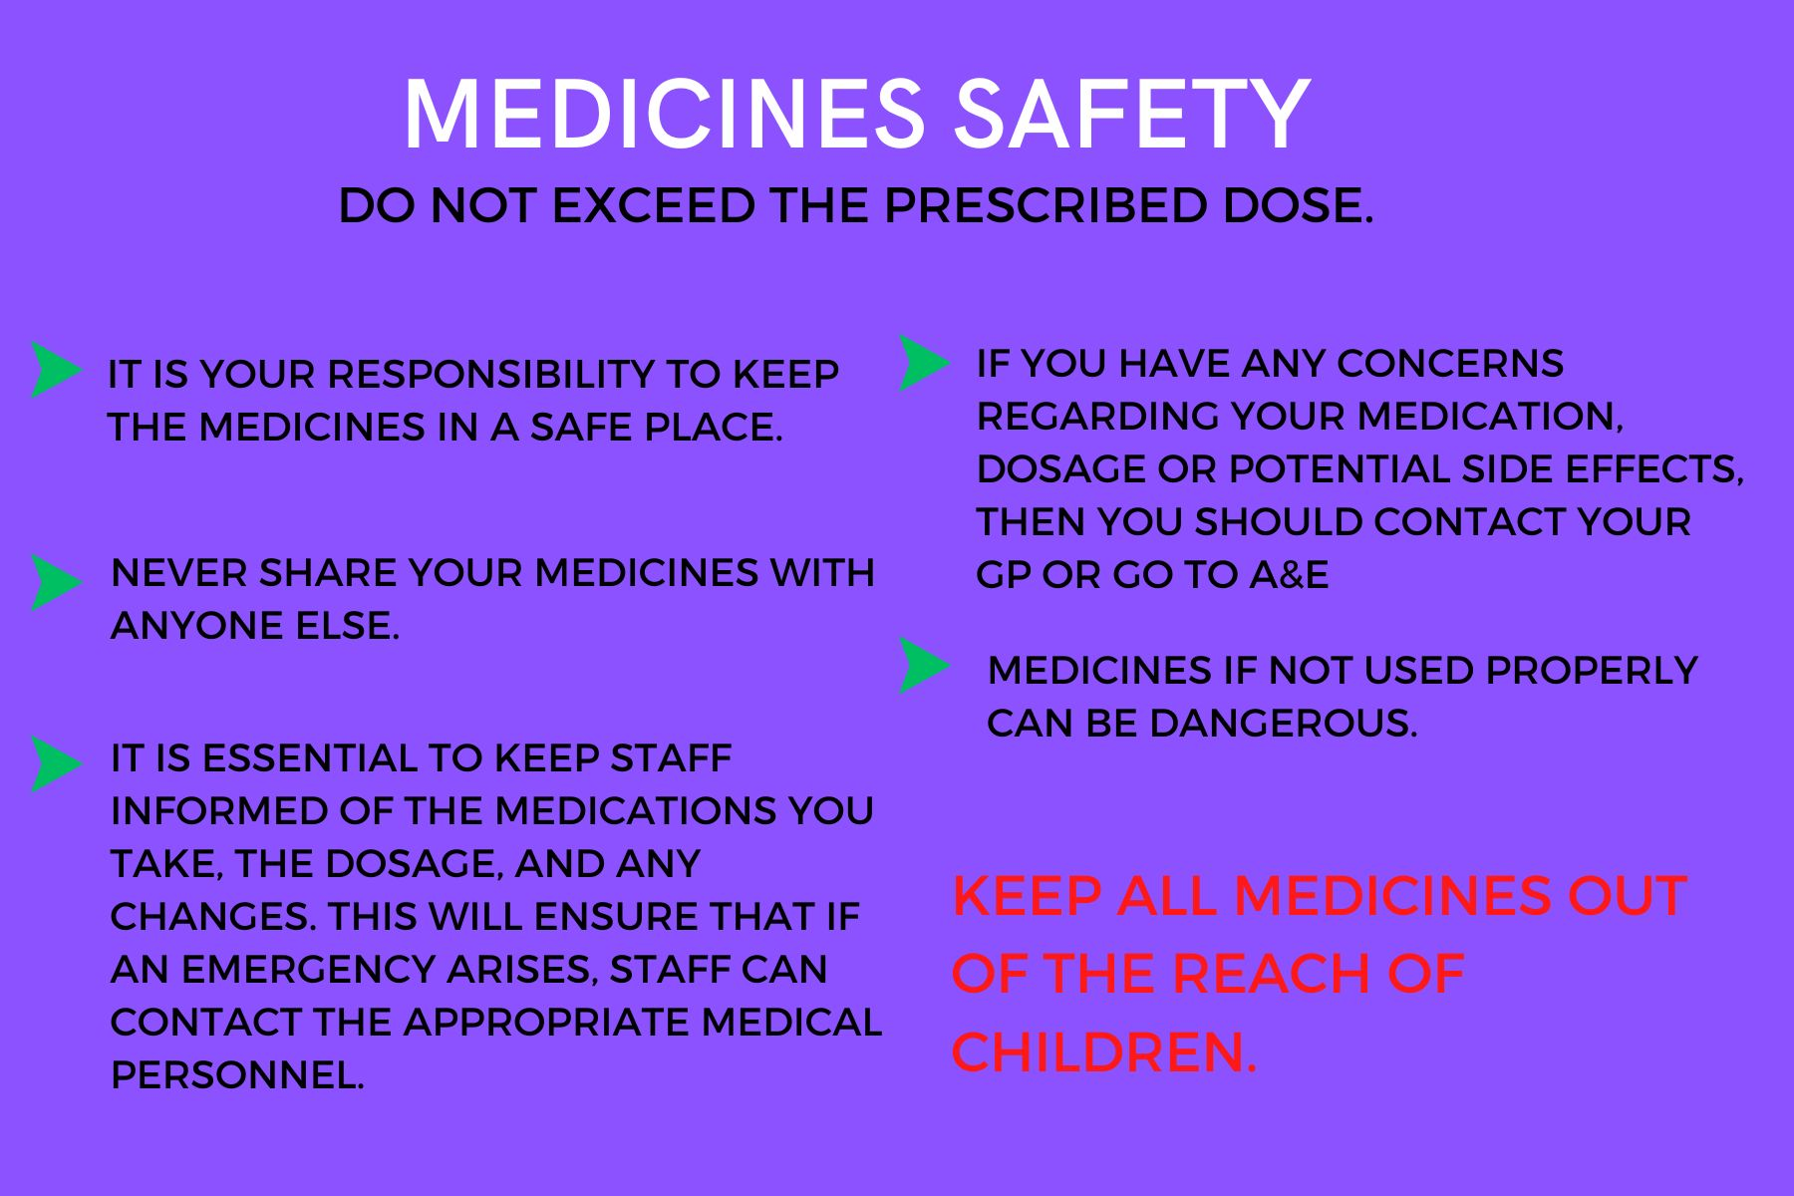

Self-Administration of Medicines - Form

Resident Name: Date of Birth: | ………………………………………………………………………………………..  …………………………………………………………………………………………
Assessment Criteria |  | Yes | No
What medication is the resident currently taking? What is it used for?

Has the resident expressed a wish to self-medicate?
Is the resident mentally and physically able to self-medicate?
Can the resident open child resistant lids/blister strips, use their eye drops and inhalers, etc?
Can the resident read a label?
Is the resident responsible for administering their medication at present?
Does the resident know: | What dosage to take?
Does the resident know: | How to take the medication?
Does the resident know: | Has the resident read and understood the SAM leaflet?
Does the resident know: | What to do if their supply runs out?

Self-administration of medicines (SAM)

RESIDENT CONSENT FORM

Resident Name: Date of Birth: | ………………………………………………………………………………………………  ………………………………………………………………………………………………

- I have read and understood the resident information leaflet.
- The self-administration of medicines scheme has been fully explained to me by Voyant Ventures staff, I am willing to take responsibility for my medication.
- I understand that I MUST NOT share my medication with anyone.
- I know I must inform staff immediately if someone else tries to take my medicines.
- I understand that I may withdraw from the scheme at any time without prejudice by informing staff.
- I agree to accept responsibility for the safe keeping of my medicines and any consequence of failing to take my medication in the prescribed way.

Print Name
Resident Signature
Print Name
Staff Signature
Date

